Participant guide to booking on course through my.HR

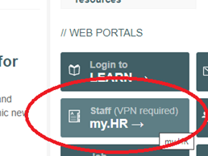
Navigating to my.HR
As a member of staff you will have access to the Universities my.HR page, this portal provides an area for you to easily book onto courses. This guide will show you how to book onto a course through my.HR.
To access you will need to go to the main Universities webpage and on the right-hand side click on the button labelled ‘my.HR’ which you can see above.
If not on campus you will need to log onto the VPN, you can access a guide on how to do this on the ITS webpage, searching for ‘Off campus Access’.
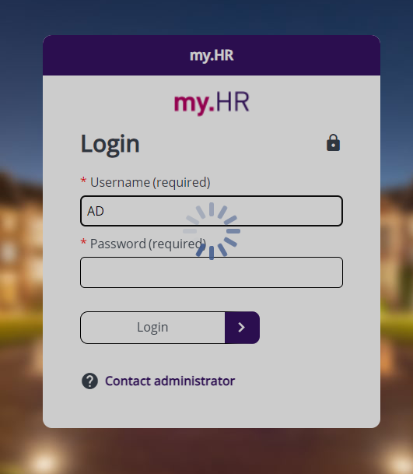
Signing in
It will then take you to the page where it will automatically log you in, or you will you will need to enter in your staff username and password. If you’re having trouble logging in please contact the iTrent team.
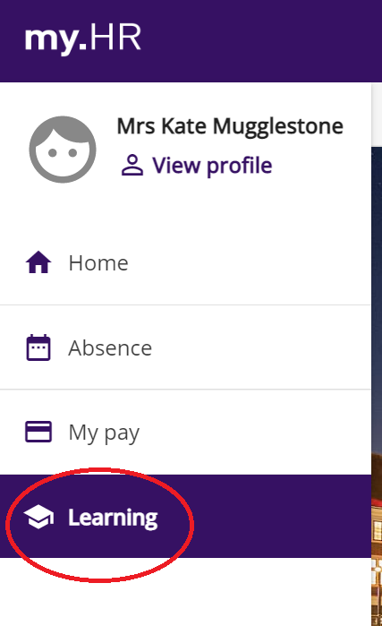

Booking onto course
At the top you will notice a few options to choose from, click on ‘Learning.’
You will then be able to search for a course on the right-hand side of the page. Type in part or the full title of the course in the ‘keywords’ and then click ‘search’. All available courses will appear below for you to then select.
Click onto the relevant course. You will then have the option of ‘book onto course’ or ‘add to waiting list.’

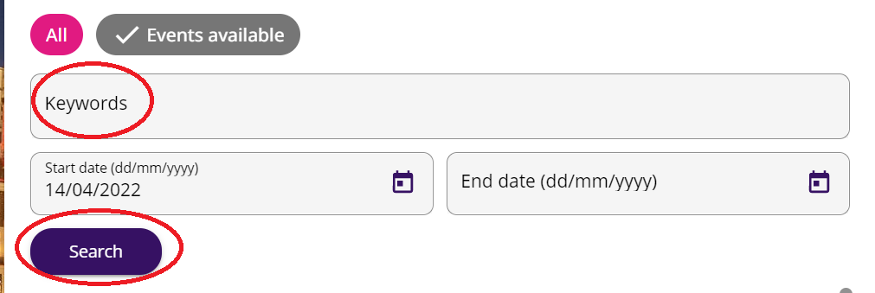
For both you will need to select from the dropdown options the ‘origin of request’ and ’reason’ before then clicking ‘save.’

Looking at courses booked onto
This will then appear on your ‘Learning’ page under ‘My activities.’
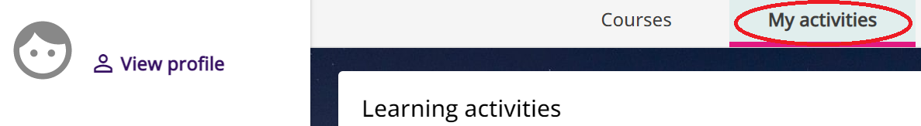
Cancelling your booking
To cancel your booking, you will need to click on the particular event, select the reason from the dropdown menu and ‘save.’
Troubleshooting
If you have any issues, please email OD@lboro.ac.uk with and explanation of the issue you are having.

